

Electronic Portfolio Exam

Advanced Placement Art

Ms. Ginnitti

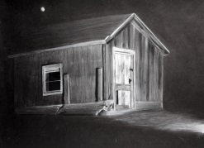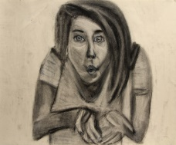

The Contents:

* Please be sure to include photographs of what is listed below. All should be labeled with a title, size and media.
* 12 Breadth which could include the following from this year:

*Still life in Charcoal*

*Portrait of an Object (x3 drawings)*

*Variety drawing of fruit or vegetable*

*Phases Drawing*

*Repetition and multiples*

*Psychological space*

*Self Portrait Drawing*

*Sketchbook entries*

* 12 concentrations
* Please feel free to make sections for artwork you created in other classes as well!

*As a final exam for the course, you will be creating a* ***Weebly*** *portfolio website.*

*The URL to set up the site is:* **http://www.weebly.com/**

The Written Stuff:

Create an “about the artist” section and in it write an artist statement to share some insight into who you are as an artist. The format is as follows (each paragraph should be 3-5 sentences):

1. *Your inspirations* (What or who inspires your artwork? Explain.)
2. *Conceptual meaning* (Write about the conceptual meaning behind some of your artwork. You might want to site one or two specific artworks. This might be a good time to write a little about your concentration.)
3. *Exploring Technique* (Write about the methods and materials you prefer working with and why. Explain your technique and again site some examples of your more successful pieces.)
4. *Today and Beyond* (Write a philosophy about the importance of art. How does it influence you in and outside of the class? Try and turn this into a closing statement.

Setup Tips:

Be sure you use an email that you have access to and be sure to use a password that you will remember.

Organize the site in a way that works for you and highlights your expertise in the more appealing way. Just make sure all the content is included.

It’s important to know:

** Please note:  Do not put any personal information on your portfolio site. It should contain only your artwork and your statements.  This is the Internet... all is available for anyone to access.  Be safe!

*** If you choose not to create an online portfolio, feel free to create your portfolio using PowerPoint.  Just be sure that all you include ALL of the required information and imagery as it is listed above.

555.555.5555

555.555.5555

555.555.5555

email@address.com

www.webaddress.com