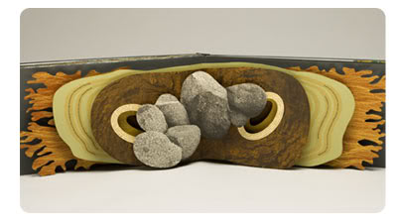
Artist statement
Sculptural Artist Books
Ms. Ginnitti, Creative Crafts

Now that we have completed our unit on artist books and you have created your own work of art, you will need to reflect on your completed project and the creative process you went through in a final artist statement. Your statement will be exhibited alongside your final artwork during the critique so please write legibly and clearly. Use the back of this paper for your final artist statement. Follow the format below when writing your paragraphs. Keep each paragraph down to 3-5 sentences. This is not meant to be long. Being clear and concise is more important than being lengthy.

Paragraph 1- What your artist book about.
- What theme did you choose to interpret and where did you get your idea/inspiration?
- What message were you trying to communicate through your artist book and how did you go about showing that?

Paragraph 2- The decisions you made while creating the artwork.
- Explain the reasons for the way you created the cover, binding, and/or pages. What materials did you use and why?

Paragraph 3- The inspirations for the artwork.
- How is your book similar and different from the books created by Julie Chen? Think about your process, materials, and ideas as compared to her’s.

Paragraph 4- Your success.
- Are you pleased with how your book turned out in comparison to your original plan?
- Was this artwork successful in communicating your theme and overall idea?
- In retrospect, what improvements do you think could be made to your process of working or to your final project?

Your name: ____________________________________ Book title: ______________________

__________________________________________________________________________________________________________________________________________________________________________________________________________________________________________
__________________________________________________________________________________________________________________________________________________________________________________________________________________________________________
__________________________________________________________________________________________________________________________________________________________________________________________________________________________________________
__________________________________________________________________________________________________________________________________________________________________________________________________________________________________________
__________________________________________________________________________________________________________________________________________________________________________________________________________________________________________
__________________________________________________________________________________________________________________________________________________________________________________________________________________________________________
__________________________________________________________________________________________________________________________________________________________________________________________________________________________________________
__________________________________________________________________________________________________________________________________________________________________________________________________________________________________________
__________________________________________________________________________________________________________________________________________________________________________________________________________________________________________
____________________________________________________________________________________________________________________________________________________________
______________________________________________________________________________
____________________________________________________________________________________________________________________________________________________________

