Name: ____________________________________________ Period: _________

Digital Photography I
Combining it all to make a proper exposure.

Aperture, Shutter Speeds, & ISO combinations
The photographer’s goal is to determine what any given ISO and any given lighting condition will produce a successful image. If it is a cloudy day, we must let more light hit the sensors. This can be achieved in a number of ways. We can let in more light with a larger aperture, or we can keep a smaller aperture and slow our shutter speed down, or we can change our ISO speed for more sensitivity. The goal is to find the correct combination to make a proper exposure. The histogram of a properly exposed image looks like this:
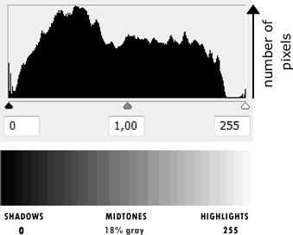

Light meters
We know how much light to allow to hit our sensors because of the camera’s light meter. Most cameras have a built in light meter that tells the camera how much light is being reflected into the camera by the scene. By lightly pressing your shutter, you will get an overall average reading from your camera telling you what combination of shutter speed and aperture to use with your ISO speed. This average reads for a middle gray tone.

Equivalency Exposure
What if you want to get a shallow depth of field (where the background is out of focus), but it is really bright outside? By increasing the shutter speed, you can use a larger aperture opening. This also works in reverse. If you want to have a greater depth of field (where everything is in focus), use a slower shutter speed. BUT… you must always keep in mind how your shutter speed will affect movement. Helpful hint: Never try to photograph without a tripod or stable support at speeds of 1/30th of a sec or slower!
Try out the equivalency exposures listed here. The original shutter speed and aperture chosen are properly exposed for that specific lighting condition but the photographer wants to alter them to achieve a different desired affect. In the chart below, fill in the blanks. Use the information from your notes on apertures and shutter speeds to help you count your stops.

Situation 1: Photographing a flower outside in a park under normal daytime light with an ISO of 100.
 | Original | Photographer wants shallower depth of field (or a blurry background.) | Equivalency
Aperture | f-16 |  | f-5.6
Shutter speed | 1/125 |  | 1/1000

Situation 2: Indoors at a party under moderate lighting in the early evening with an ISO of 400.
 | Original | Photographer wants to show more motion blur of people dancing. | Equivalency
Aperture | f-4 |  | F-11
Shutter speed | 1/125 |  | 1/15

Tips
- Be certain you have enough light to make each exposure.
- Remember that the camera will move with a long exposure, so use a tripod or stable surface.
- Do NOT be afraid to try anything… it’s digital!
- Take lots of photos! Again, it’s DIGITAL!

