Name: ____________________________________________ Period: _________
How to make an exposure: an introduction.

Digital Photography I

Requirements to make a picture:
- Light
- A light tight box
- A light sensitive surface such as film or digital sensors
- A lens and means of controlling the amount of light that reaches the film or sensors.

Facts to Remember:
- Exposure is the amount of light that is allowed to hit the film or the image chip in the digital camera when you take the photograph. Exposure is measured in increments called stops.
- Three things control the exposure: the amount of light the camera allows in (f-stop or aperture), the length of time that the light is allowed into the camera (shutter speed), and the films sensitivity to light (film speed or ISO).

Aperture:
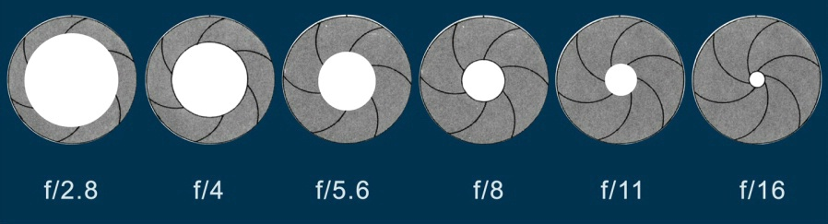
The intensity of the light reaching the film is controlled by lens openings called apertures. The openings are measured in numeric intervals called “f-stops”. The smaller aperture openings allow the least amount of light to reach the film or sensors. Apertures or “f-stops” also control depth of field. The smaller the aperture, the greater the depth of field (everything is in focus). The larger the aperture, the less depth of field (the background is out of focus).

Smaller aperture=
Bigger number
FARTHER clarity
Less light
Larger aperture=
Small number
SHALLOW clarity
More light

Shutter Speed:
Time is controlled by the camera’s shutter speeds. The shutter speeds on your camera are fractions of a second. For example, 250 means 250th of a second. Each shutter speed is exactly twice as fast as the one preceding it and allows half as much light into the camera. Shutter speeds also control motion and movement. A slower shutter speed will record the blur of movement; a faster shutter speed will stop motion and movement in action.

1/2000 | 1/1000 | 1/500 | 1/250 | 1/125 | 1/60 | 1/30 | 1/15 | 1/8 | 1/4 | 1/2 | 1 | 2 | 4 | 8 | 16
Shorter amount of time Longer amount of time (can be hand held) (use a tripod under 1/30)

ISO / FILM SPEED:
ISO is the “international standards organization” designation of film speeds. The higher the ISO number, the more sensitive to light. Higher ISO settings require less light in order to achieve a proper exposure. The lower ISO settings are less sensitive to light and therefore require more light to get a proper exposure. HOWEVER, with the good comes the bad… The higher the ISO (ex. 800 speed), the more film gram or pixilation you will have.

