Linear Perspective Drawing Reflection
Art Design, Name: _________________________________________________

- In the space below, do a quick sketch of your final artwork and please label the linear perspective tools you used to create this image. For example, label the vanishing point(s), orthogonal lines, and horizon line.

- Discuss your artwork below. For example, think about the following questions as you write: What is the location? Why did you choose it? Does it have significance? What were you trying to communicate? Why did you choose the material you chose? Etc.

- On a scale of 1-10, (1 being easy and 10 being difficult), please describe the difficulty level of your linear perspective artwork. To be clear, I’m not asking how hard it was for you to do. I’m, instead, looking for how challenging you think the linear perspective method was to reproduce. For example, a corner of a complex 2 point perspective building is a much higher level of difficulty than an empty road with one vanishing point.
Score your difficulty level here. ________________.

- Take a look at this artwork called Chair Car by Edward Hopper. Please label the vanishing point(s), orthogonal lines, and horizon line. Then answer the questions about this work below.

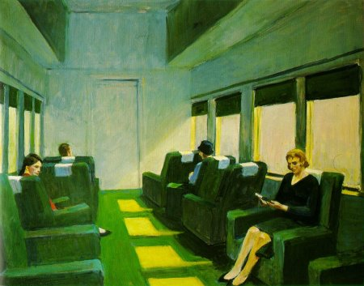

- In 3-5 sentences, write an analysis of Chair Car. Be sure to cite specific elements and principles.

- In 3-5 sentences, write an interpretation of Chair Car. Start with what you think the mood of the artwork is and why.

